Agile Software Development Process

Principles of Agile:
- The highest priority is to satisfy the customer through early and continuous delivery of valuable software.
- It welcomes changing requirements, even late in development.
- Deliver working software frequently, from a couple of weeks to a couple of months, with a preference for the shortest timescale.
- Build projects around motivated individuals. Give them the environment and the support they need and trust them to get the job done.
- Working software is the primary measure of progress.
- Simplicity the art of maximizing the amount of work not done is essential.
- The most efficient and effective method of conveying information to and within a development team is face-to-face conversation.
- By the amount of work that has been finished, gauge your progress.
- Never give up on excellence.
- Take advantage of change to gain a competitive edge.

The Agile Software Development Process:
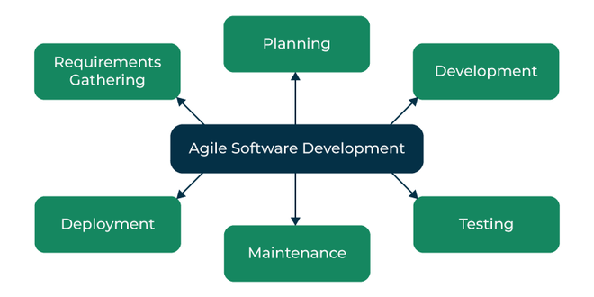
Agile Software Development
- Requirements Gathering: The customer’s requirements for the software are gathered and prioritized.
- Planning: The development team creates a plan for delivering the software, including the features that will be delivered in each iteration.
- Development: The development team works to build the software, using frequent and rapid iterations.
- Testing: The software is thoroughly tested to ensure that it meets the customer’s requirements and is of high quality.
- Deployment: The software is deployed and put into use.
- Maintenance: The software is maintained to ensure that it continues to meet the customer’s needs and expectations.
Agile Software Development is widely used by software development teams and is considered to be a flexible and adaptable approach to software development that is well-suited to changing requirements and the fast pace of software development.
Agile is a time-bound, iterative approach to software delivery that builds software incrementally from the start of the project, instead of trying to deliver all at once.

Let’s see a brief overview of how development occurs in Agile philosophy.
- concept
- inception
- iteration/construction
- release
- production
- retirement

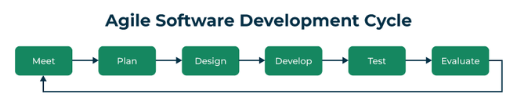
Agile software development cycle
- Step 1: In the first step, concept, and business opportunities in each possible project are identified and the amount of time and work needed to complete the project is estimated. Based on their technical and financial viability, projects can then be prioritized and determined which ones are worthwhile pursuing.
- Step 2: In the second phase, known as inception, the customer is consulted regarding the initial requirements, team members are selected, and funding is secured. Additionally, a schedule outlining each team’s responsibilities and the precise time at which each sprint’s work is expected to be finished should be developed.
- Step 3: Teams begin building functional software in the third step, iteration/construction, based on requirements and ongoing feedback. Iterations, also known as single development cycles, are the foundation of the Agile software development cycle.

